Official installation: <https://developers.google.com/maps/documentation/android/start>

1. <https://console.developers.google.com/project> create a project
2. Enable Google Map API v2
3. generate debug.keystore

keytool -genkey -v -keystore debug.keystore -alias androiddebugkey -storepass android -keypass android -keyalg RSA -validity 14000

put key to eclipse -> Window -> Preferences

copy SHA1 code to <https://console.developers.google.com/project/apps> and generate android key

1. using Android SDK Manager and install Extra -> Android Support Library and Google Play Services and install android 4.2.2 (or later) Google APIs.
2. import %anroid_sdk_home%\ \extras\google\google_play_services\libproject\google-play-services_lib project to eclipse
3. right click google-play-services_lib project, and choose Properties -> Android, add android version libraries to Project Build Target

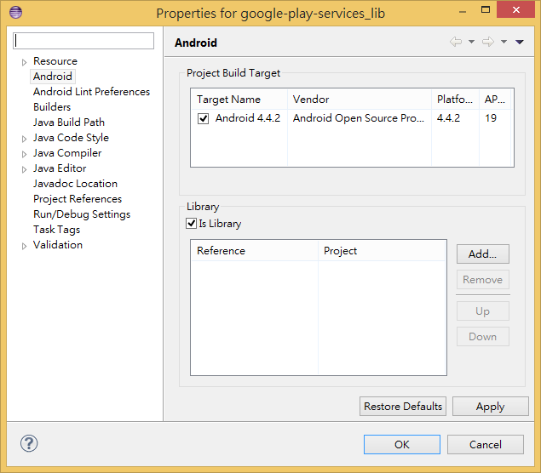

1. edit AndroidManigest.xml add permission:

<uses-permission android:name="android.permission.INTERNET" />

<uses-permission android:name="android.permission.ACCESS_NETWORK_STATE" />

<uses-permission android:name="android.permission.WRITE_EXTERNAL_STORAGE" />

<uses-permission android:name="com.google.android.providers.gsf.permission.READ_GSERVICES" />

<!--

The following two permissions are not required to use

Google Maps Android API v2, but are recommended.

-->

<uses-permission android:name="android.permission.ACCESS_COARSE_LOCATION" />

<uses-permission android:name="android.permission.ACCESS_FINE_LOCATION" />

<application>

…

<meta-data

android:name="com.google.android.maps.v2.API_KEY"

android:value="put android key get from google project" />

</application>